**Chronic Pain – Prescriber Resources Update**

1. **LSCICB has recently agreed to host and approve for use a new resource pack on Opioid Prescribing for Chronic Pain*. Access to the resource pack can be found at** [NHS Greater Manchester Integrated Care - Opioid Prescribing for Chronic Pain: Resource Pack (gmmmg.nhs.uk)](https://gmmmg.nhs.uk/wp-content/uploads/2023/12/Opioid-resource-pack-2023-final-for-web.pdf). **Amongst other things, the resource pack provides guidance on:**

* Managing patient expectations of treatment
* What to discuss with the patient when considering opioid treatment
* Arrangements for, and content of medication reviews
* Stopping opioids in Primary Care

The resource pack also contains a useful Summary of NICE Guidance related to Pain Relief and the very limited role of Opioids (Appendix 6)

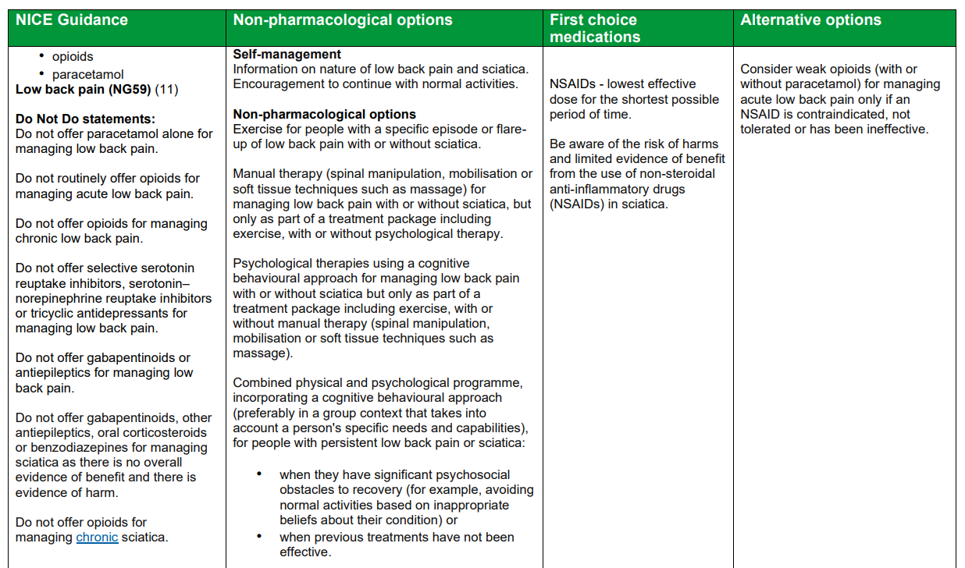

1. **The LSCICB Medicines Management Team has collaborated with colleagues from the prescribing support software tool Optimise Rx, to create an alert reflecting the LSCMMG position statement on the maximum doses of morphine equivalent that could be trialled in Primary Care.**

The best practice message encourages and supports the safer use of opioids by alerting clinicians when attempts are made to prescribe an opioid which exceeds the 80mg MED (Morphine Equivalent Daily Dose) maximum recommended in Primary Care by local pain specialists.

Reference information is also included in the message which navigates clinicians to the following webpages: [LSCMMG Chronic Pain Patient Resources](https://www.lancsmmg.nhs.uk/clinical-resources/patient-resources/chronic-pain-patient-resources/), [LSCMMG Chronic Pain Prescriber Resources](https://www.lancsmmg.nhs.uk/clinical-resources/prescriber-resources/chronic-pain-prescriber-resources/), [LSCMMG High dose morphine prescribing for chronic non-cancer pain position statement](https://www.lancsmmg.nhs.uk/media/1679/high-dose-morphine-prescribing-for-chronic-non-cancer-pain-position-statement.pdf) and the [Faculty of Pain Medicine webpage on dose equivalencies](https://www.fpm.ac.uk/opioids-aware-structured-approach-opioid-prescribing/dose-equivalents-and-changing-opioids)

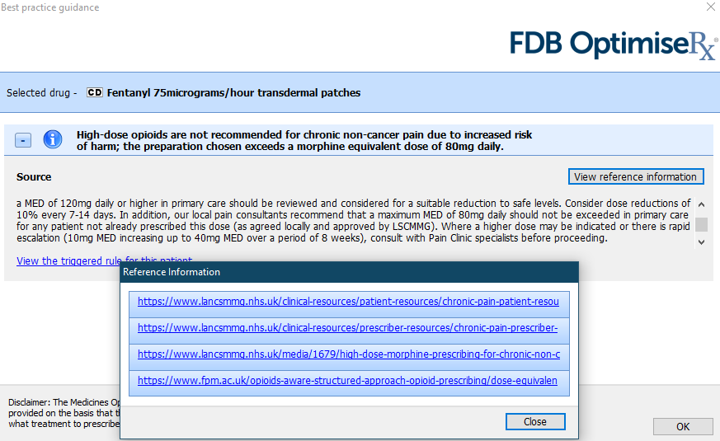

1. **To encourage the systematic review of patients taking opioids within LSCICB, the Medicines Management Team would like to highlight the availability of a Chronic Pain Management review template on EMIS.**

The Chronic Pain Management (v18.45) (Ardens) template can be found on the template picker and encourages clinicians to consider: a biopsychosocial assessment, mental health co-morbidities, pharmacological/non-pharmacological management options and if appropriate a tapering/stopping plan. The template also has a built-in resource and patient messaging section, which allows clinicians to provide information directly to patients on self-management strategies.

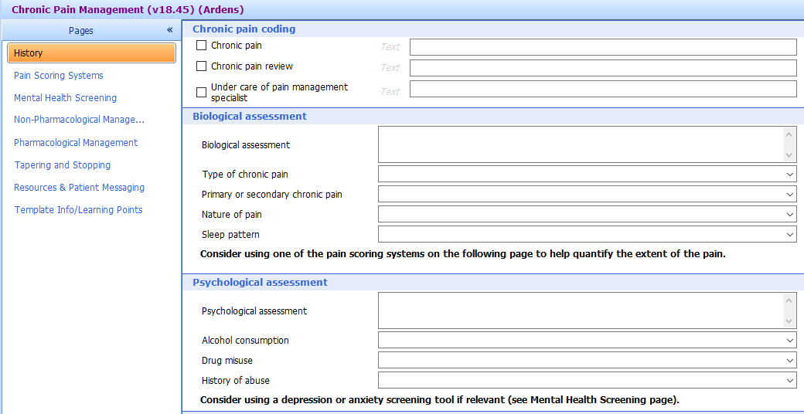

* with permission from NHS Greater Manchester Integrated Care